ASTA 607
22424275
End of Semester Examination
Question 1
- Describing the crabs dataset
?crabs

The crabs data frame has 200 rows and 8 columns, describing 5 morphological measurements on 50 crabs each of two colour forms and both sexes, of the species Leptograpsus variegatus collected at Fremantle, W. Australia.
Campbell, N.A. and Mahon, R.J. (1974) A multivariate study of variation in two species of rock crab of genus Leptograpsus. Australian Journal of Zoology 22, 417–425.

- Loading the dataset and displaying its structure
data("crabs")

str(crabs)

Output:
'data.frame': 200 obs. of 8 variables:
$ sp : Factor w/ 2 levels "B","O": 1 1 1 1 1 1 1 1 1 1 ...
$ sex : Factor w/ 2 levels "F","M": 2 2 2 2 2 2 2 2 2 2 ...
$ index: int 1 2 3 4 5 6 7 8 9 10 ...
$ FL : num 8.1 8.8 9.2 9.6 9.8 10.8 11.1 11.6 11.8 11.8 ...
$ RW : num 6.7 7.7 7.8 7.9 8 9 9.9 9.1 9.6 10.5 ...
$ CL : num 16.1 18.1 19 20.1 20.3 23 23.8 24.5 24.2 25.2 ...
$ CW : num 19 20.8 22.4 23.1 23 26.5 27.1 28.4 27.8 29.3 ...
$ BD : num 7 7.4 7.7 8.2 8.2 9.8 9.8 10.4 9.7 10.3 ...

This is to view the first few rows of the dataset
head(crabs)

Output:
sp sex index FL RW CL CW BD
1 B M 1 8.1 6.7 16.1 19.0 7.0
2 B M 2 8.8 7.7 18.1 20.8 7.4
3 B M 3 9.2 7.8 19.0 22.4 7.7
4 B M 4 9.6 7.9 20.1 23.1 8.2
5 B M 5 9.8 8.0 20.3 23.0 8.2
6 B M 6 10.8 9.0 23.0 26.5 9.8

- Frequency tables for species
(table_sp <- table(crabs$sp))

Output:
B O
100 100

Frequency tables for sex
(table_sex <- table(crabs$sex))

Output:
F M
100 100

- Mosaic Plot summarizing the group composition
mosaic <- mosaicplot(table(crabs$sp, crabs$sex), main = "", xlab = "Species",
ylab = "Sex", col = c(18,5))

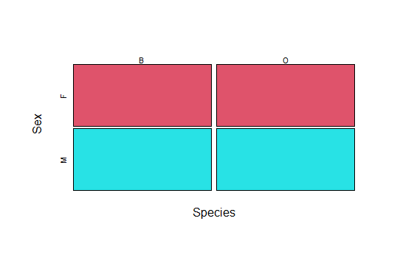
Figure 1. Mosaic Plot: Species vs Sex
- The dataset is balanced across the four groups. Each group (Blue Male, Blue Female, Orange Male, Orange Female) has exactly 50 crabs.

Question 2
- Constructing a side-by-side boxplots of body depth for the four groups defined by species and sex

boxplot(BD ~ sp * sex, data = crabs, main = "",
xlab = "Species and Sex", ylab = "Body Depth", col = c(28,42))

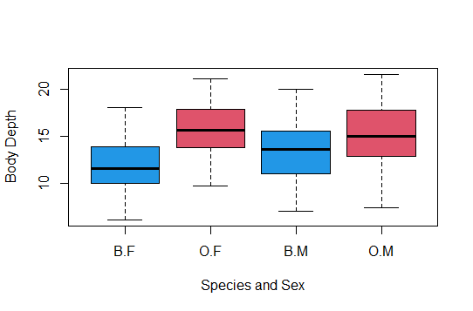
Figure 2. Boxplots of BD by species and sex
- From the side-by-side boxplots, there are no noticeable outliers, as no observations extend substantially beyond the whiskers. The central tendency, indicated by the median lines within each box, differs slightly across the four groups. Overall, male crabs tend to have higher median body depth values compared to females, and minor differences are also evident between the two species.
In terms of variability, reflected by the size of the boxes (IQR) and the length of the whiskers, the spread appears fairly consistent across groups. Although one or two groups show a marginally wider spread, suggesting slightly greater variation, the differences are not substantial.
In summary, the boxplots do not reveal any extreme or unusual observations. While there are modest differences in median body depth—particularly with males generally exhibiting greater depth than females—the overall variability within each group is quite similar. The groups therefore differ slightly in central location but display comparable dispersion.

Question 3
- Producing a histogram of carapace length (CL) for species B
hist(crabs$CL[crabs$sp == "B"], main = "",
xlab = "Carapace Length", col = 2)

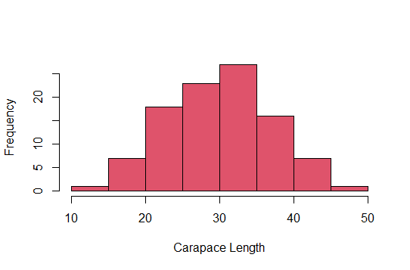
Figure 3. Histogram of Body Depth for Species B

A histogram of carapace length for species O
hist(crabs$CL[crabs$sp == "O"], main = "",
xlab = "Carapace Length", col = 7)

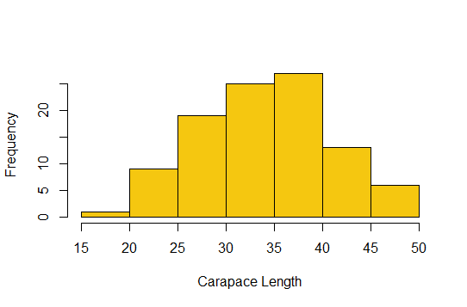
Figure 4. Histogram of Body Depth for Species O
b) Blue Species (B):
The histogram for the blue crabs appears approximately symmetric and resembles a bell-shaped distribution. Most observations cluster around the mean carapace length, producing a single prominent peak. There are no noticeable long tails or extreme observations, indicating little skewness.
Orange Species (O):
The histogram for the orange crabs shows a slightly different pattern. It exhibits mild right skewness, suggesting that a few crabs have relatively larger carapace lengths. Similar to the blue species, the distribution is mainly unimodal; however, there is a slight suggestion of a secondary, smaller peak, which may indicate the presence of subgroups within the species.
Summary:
In general, the blue crabs display a fairly symmetric and evenly distributed pattern of carapace lengths, whereas the orange crabs demonstrate slight positive skewness and possible additional variation in size. This suggests that carapace length distributions differ somewhat between the two species, potentially due to biological, genetic, or environmental influences.

Question 4
- Mean of each morphological measurement by species and sex
mean_measurement <- crabs %>%
group_by(sp, sex) %>%
summarise(mean_CL = mean(CL),
mean_CW = mean(CW),
mean_BD = mean(BD),
mean_FL = mean(FL),
mean_RW = mean(RW))
print(mean_measurement)

Output:
sp sex mean_CL mean_CW mean_BD mean_FL mean_RW
<fct> <fct> <dbl> <dbl> <dbl> <dbl> <dbl>
1 B F 28.1 32.6 11.8 13.3 12.1
2 B M 32.0 36.8 13.4 14.8 11.7
3 O F 34.6 39.0 15.6 17.6 14.8
4 O M 33.7 37.2 15.3 16.6 12.3

- Constructing a grouped bar chart to display these means
barplot(mean_measurement$mean_CL,
names.arg = paste(mean_measurement$sp, mean_measurement$sex),
main = "Mean Carapace Length by Species",
xlab = "Species and Sex", ylab = "Mean Carapace Length", col = c(1:10))
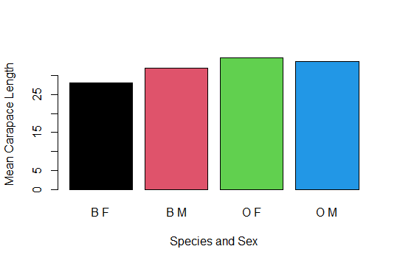
Figure 5. Mean Carapace Length by Species
- The Orange Female shows the greatest species difference while the Blue Female shows the least sex variation.

Question 5
- Scatterplot matrix of the five measurements
pairs(crabs[, c("CL", "CW", "BD", "FL", "RW")], main = "",
pch = 1 [as.numeric(crabs$sp)])

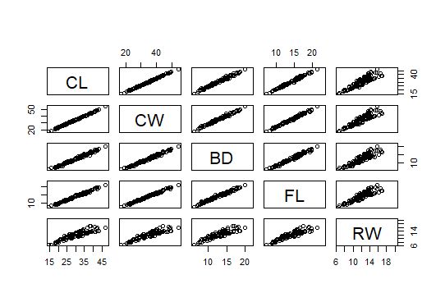
Figure 6. Measurements
- 1. Strength of Relationships
All pairs of variables show a strong positive linear relationship.
The points in each scatterplot cluster tightly along a straight line, which indicates high correlation between the variables.
2. Nature of Relationships
Positive Relationship: In every scatterplot, as one variable increases, the other variable also increases.
Linear Relationship: Most plots show points aligned roughly along a straight line, suggesting linear associations. No obvious curvature or nonlinear patterns are visible.
Conclusion: The five variables are all positively and strongly correlated, and their relationships are largely linear. This suggests that changes in one variable are consistently associated with proportional changes in the others.

Question 6
Comprehensive Statistical Report
Analysis of Crab Morphological Measurements
The crabs dataset from the MASS package contains measurements of 200 crabs, evenly distributed between two species (Blue and Orange) and both sexes (Male and Female). Five morphological traits were recorded: Frontal Lobe size (FL), Rear Width (RW), Carapace Length (CL), Carapace Width (CW), and Body Depth (BD). This report investigates species and sex differences, examines distribution patterns of measurements, and explores relationships among the five traits.

Differences by Species and Sex
A side-by-side boxplot of Body Depth (BD) reveals that males consistently exhibit greater body depth than females, with species differences also apparent. No significant outliers are present, and within-group variability remains relatively consistent across all four categories. Mean values calculated for all five traits support these visual observations. Carapace Length (CL) demonstrates the most substantial difference between species, while Frontal Lobe size (FL) shows the smallest disparity between sexes. A grouped bar chart of the mean values effectively illustrates these patterns, enabling straightforward comparison across groups.

Distribution of Carapace Length
Histograms of Carapace Length (CL) reveal distinct distributional characteristics for each species. Blue crabs display an approximately symmetric, bell-shaped distribution, with observations concentrated near the mean. Orange crabs exhibit mild positive skewness, indicating a subset of individuals with larger-than-average carapace lengths. Both species show primarily unimodal distributions, though Orange crabs suggest a possible secondary peak, hinting at potential subgroup structure.
Relationships Among Measurements
Scatter plots examining all five traits reveal strong positive correlations among them. Increases in one measurement are consistently associated with increases in others; for instance, specimens with longer carapaces typically also have wider carapaces and greater body depth. These relationships appear predominantly linear throughout the observed range, with no aberrant points disrupting the overall patterns. This coherence indicates that larger crabs maintain proportionally larger dimensions across all measured traits.

Conclusions
The analysis reveals distinct patterns within the data. Carapace measurements, particularly CL, prove most effective for distinguishing between species, while sex-based differences are comparatively modest, especially in frontal lobe dimensions. The strong correlations among all five measurements indicate that overall body size drives morphological variation, with larger crabs showing consistently larger values across all traits. Together, graphical displays and numerical summaries construct a coherent narrative: systematic size differences exist between species and sexes, yet all body dimensions scale together in a predictable, integrated manner.
In summary, the crabs dataset demonstrates that interspecies variation is most pronounced in carapace size, sexual dimorphism is relatively subtle, and all morphological traits are strongly interconnected. The integration of visual and quantitative approaches provides comprehensive insight into crab morphology, illuminating both the patterns of variation and the underlying consistency in their body plan organization.

